Jon Janelle

MAT 500

9/5/2013

**Chapter 2 Exercises**

**2.1**

There is no way to provide evidence to change an individual’s belief that exactly 47 angels can dance on his or her head. This is a belief about which no empirical evidence can be collected, so it is not possible to provide any observable evidence to change the belief.

It is possible that evidence could be provided to change the belief that exactly 47 anglers can dance on the floor of the bait shop since empirical evidence can be collected about this. I might first ask more than 47 anglers, say 48, to dance on the bait shop floor. If the anglers were able to complete the task, then this is sufficient evidence to change the original belief. If the 48 anglers were unsuccessful in their dance, then I would ask exactly 47 anglers to dance in the bait shop. Again, if they are unable to do this, then this would influence the original belief.

**2.2** Let X be the value of the bottom face of a tetrahedral die with sides labeled 1, 2, 3, and 4. The table below shows the values of the probability mass function P(X = x) at each value of x for three models A, B, and C.

|  |  |  |  |  |  |
| --- | --- | --- | --- | --- | --- |
| **Model** | **P(X = 1)** | **P(X = 2)** | **P(X = 3)** | **P(X = 4)** | $$\sum_{i=1}^{4}{P(x_{i})}$$ |
| **A:** P(X = x) = ¼ | ¼ | ¼ | ¼ | ¼ | 1 |
| **B:** P(X = x) = $\frac{x}{10}$ | $$\frac{1}{10}$$ | $$\frac{1}{5}$$ | $$\frac{3}{10}$$ | $$\frac{2}{5}$$ | 1 |
| **C:** P(X = x) = $\frac{12}{25x}$ | $$\frac{12}{25}$$ | $$\frac{6}{25}$$ | $$\frac{12}{75}$$ | $$\frac{3}{25}$$ | 1 |

Model A shows no bias because all outcomes are equally likely. Model B is biased toward larger face values because the outcome probability increases as the face value increases. Model C is biased toward smaller face values because the outcome probability decreases as the face value increases.

**2.3**

**A.** We roll the die 100 times and find the results #1’s = 25, #2’s = 25, #3’s = 25, #4’s = 25.

This sample would cause me to change my belief that the three models are equally likely. The proportions of each outcome in the sample are exactly the theoretical proportions predicted by model A, so we should now weight our belief in model A more heavily than in models B and C.

**B.** We roll the die 100 times and find the results #1’s = 48, #2’s = 24, #3’s = 16, #4’s = 12.

This sample would also cause me to change my belief about the three models being equally likely. The proportions of each outcome in the sample are exactly the theoretical proportions predicted by model C, so we should now weight our belief in model C more heavily than in models A and B.

**2.4** R is installed on my computer.

**2.5**

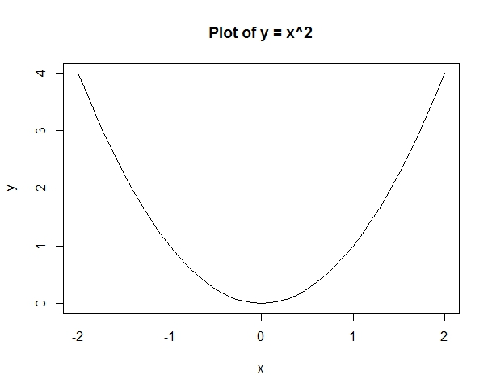

Code Listing:

#Define a vector x as a sequence from -2 to 2 with a step size of 0.1

x <- seq(from = -2, to = 2, by = 0.1)

#Define a vector y as x^2

y = x^2

#Plot the pairs (x, y) and connect successive points with lines

plot(x, y, type = 'l', main = "Plot of y = x^2")

#Graph saved as a jpeg in RStudio and imported

**2.6**

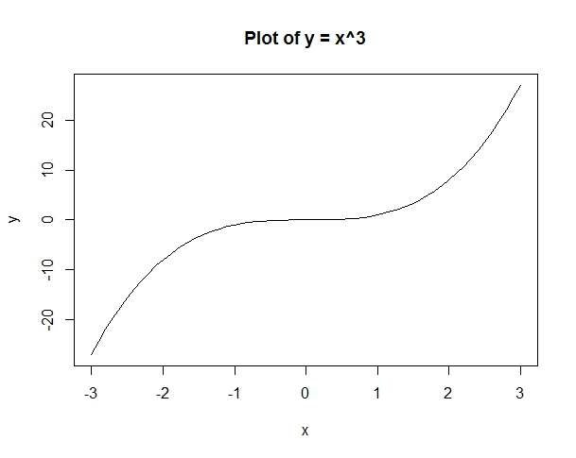

Code Listing:

#Define a vector x as a sequence from -3 to 3 with a step size of 0.1

x <- seq(from = -3, to = 3, by = 0.1)

#Define a vector y as x^3

y = x^3

#Plot the pairs (x, y) and connect successive points with lines

plot(x, y, type = 'l', main = "Plot of y = x^3")

#Graph saved as a jpeg in RStudio and imported